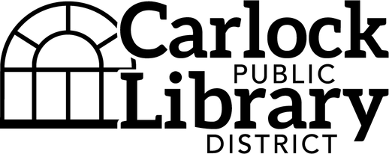
ONE STOP SUMMER EVENTS SIGN UP!
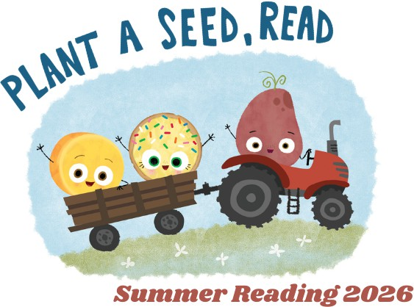
Use this form to sign up for one (or ALL!) of the many programs happening at the library this summer!
ONLINE FORM: Fill out (both sides) and drop off at the library or email to: carlocklibraryprograms@gmail.com

CONTACT INFORMATION
We will send you a confirmation email when we process your registration, and a reminder email a few days before the event. Please provide the contact information for those in your family who should receive these emails.

Parent or Guardian Name(s): _________________________________________________________ Email: _________________________________________________________________________________

PHOTO RELEASE (OPTIONAL)
We may want to share the fun we’re having on the library’s social media pages or other promotional material. Please sign this release if you’re okay sharing the fun!

Carlock Public Library District has my permission to use my or my child’s photograph from any library event to publicly promote the library. I understand that the images may be used in print publications, the library’s website, and/or social media.

Adult or Parent Signature:

Date:

Please note: All programs with registration are limited.
Sign up early to reserve your spot!

PROGRAM/EVENT | WHO’S ATTENDING? (Names, ages)
Paint a Planter: Art Camp 1
Fri, June 5 ~ 10:00 am
For ages 7 to 17
Wiggle & Learn w/ Ecology Action Ctr
Tues, June 9 ~ 1:00 pm
For ages 5 to 13
Curious Chemists
Thurs, June 11 ~ 10:00 am
For ages 5 to 13
Let’s Eat! A Cookbook Club
Thurs, June 11 ~ 4:30 pm @ Carlock Park
For adults and teens
Draw Your Own Comics: Art Camp 2
Fri, June 12 ~ 10:00 am
For ages 7 to 17
Curious Chemists
Sat, June 13 ~ 10:00 am
For ages 5 to 13
Kitchen Scrap Gardening
Mon, June 15 ~ 5:30 pm
For adults and teens
Friendship Bracelets: Art Camp 3
Fri, June 19 ~ 10:00 am
For ages 7 to 17
Darling Dolls and Lemonade
Mon, June 22 ~ 4:00 pm
For ages 4 to 12
Terrarium Fun
Wed, June 24 ~ 1:30 pm
For ages 5 to 13
Pinto Bean Portraits: Art Camp 4
Fri, June 26 ~ 10:00 am
For ages 7 to 17
Cardboard Roll Animals: Art Camp 5
Fri, July 10 ~ 10:00 am
For ages 7 to 17
Retro Night: Paint by Numbers
Tues, July 14 ~ 5:00 pm
For ages 13+
Preserving Your Harvest
Mon, July 20 ~ 5:30 pm
For adults and teens

